**Movie Ticketing Bot Powered by IBM Watson Assistant**

1. **INTRODUCTION**
   1. **Overview**

The “Movie Ticketing Bot Powered by IBM Watson Assistant” is a chatbot built using IBM Watson Assistant to book movie tickets for their customers per their requirements and availability.

* 1. **Purpose**

Customers willing to watch a movie(s) can utilize the opportunity of a bot booking ticket(s) for them. While using this chatbot, it will be easy for anyone of any age group to book a ticket compared to the traditional way of booking movie tickets.

1. **LITERATURE SURVEY**
   1. **Existing problem**

There is a solution for booking movie tickets via the app, the website, or the traditional way. The existing approach is quite exciting and easy for the younger generations. However, when we take aged people, it is difficult for them to book movie tickets. Also, in today’s world with heavy competition, it is very difficult for a regular human being to book tickets on the first few days of the release of a movie.

* 1. **Proposed solution**

An idea made to solve this sort of problem is the "Movie Ticketing Bot." The bot starts interacting with the user/customer, initially providing the list of movies that it can book for him/her. In addition, the location preference and the booking date are also quired. Based on the selection, the timings are displayed. Furthermore, the number of seats he/she wants to book for them will also be taken, and then the user's authentication will take place. Finally, if the authentication goes well, then the details of the payment are sent to the verified phone number.

1. **THEORITICAL ANALYSIS**
   1. **Block diagram**



* 1. **Hardware and Software Requirements**
* A Device with a constant internet connection.
* IBM Cloud
* IBM Watson
* Node-RED
* Flask

1. **EXPERIMENTAL INVESTIGATIONS**

A couple of investigations are done to find a solution to the problem. One is whether we should go with a predefined call bot or a chatbot. Based on the responses, many like chatbots more than call bots. Moreover, the second one is regarding the payment details, i.e., whether payment must be made using the IBM Watson or customer-satisfied payment app/website. From the feedback, it is decided that leaving the payment option to the customer would be nice.

1. **FLOWCHART**



1. **RESULT**

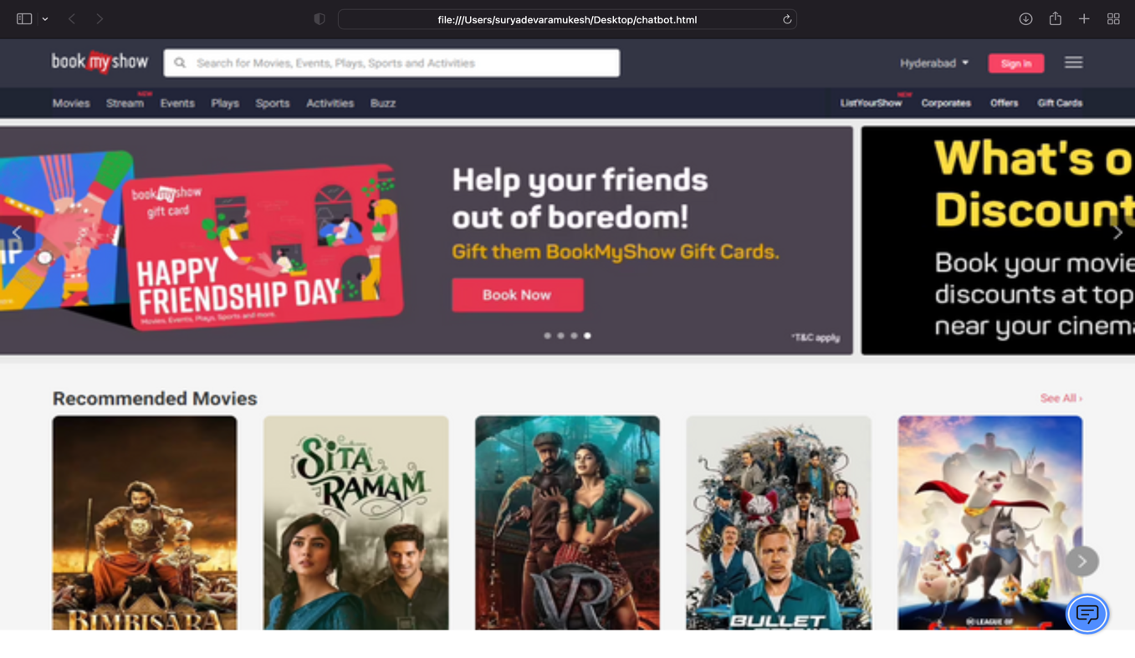

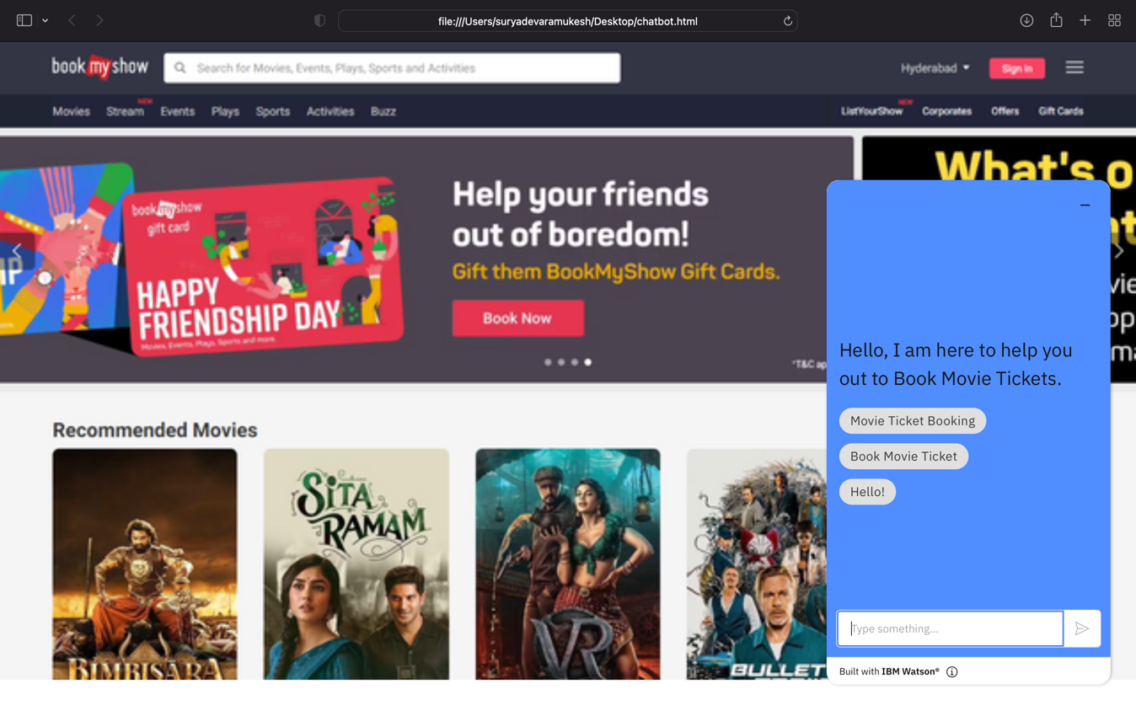

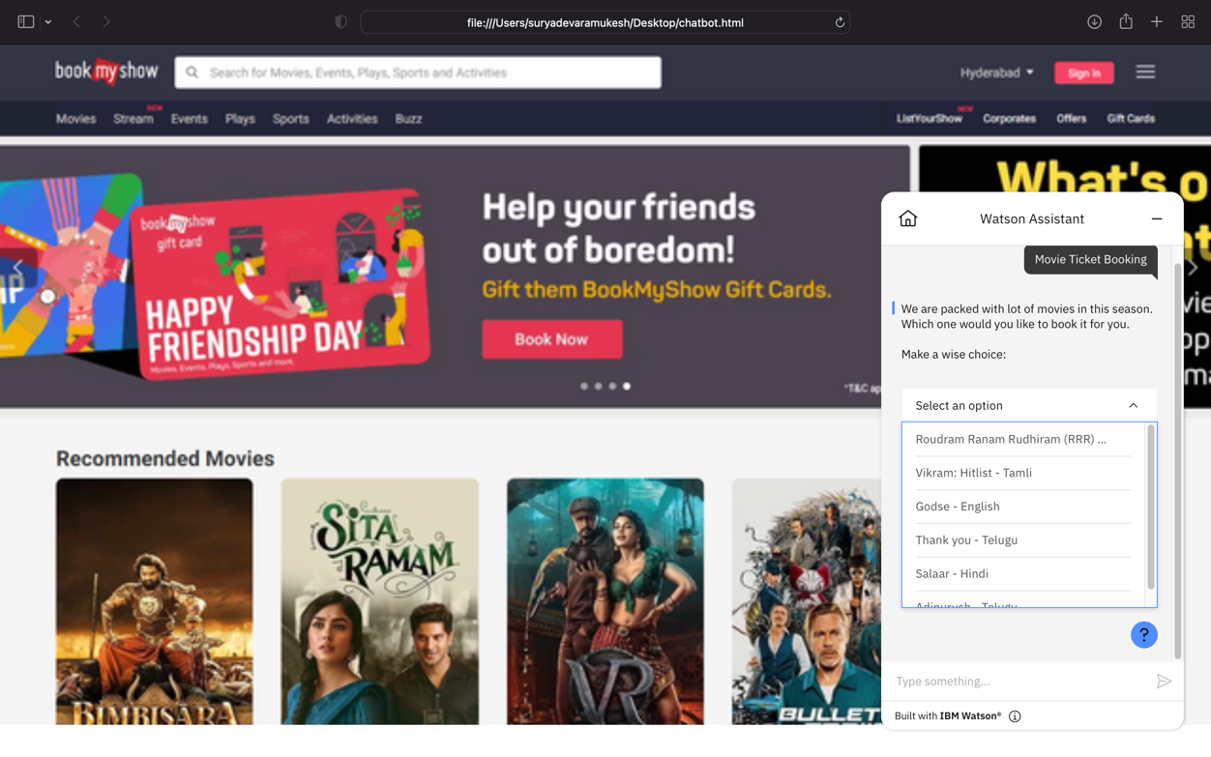

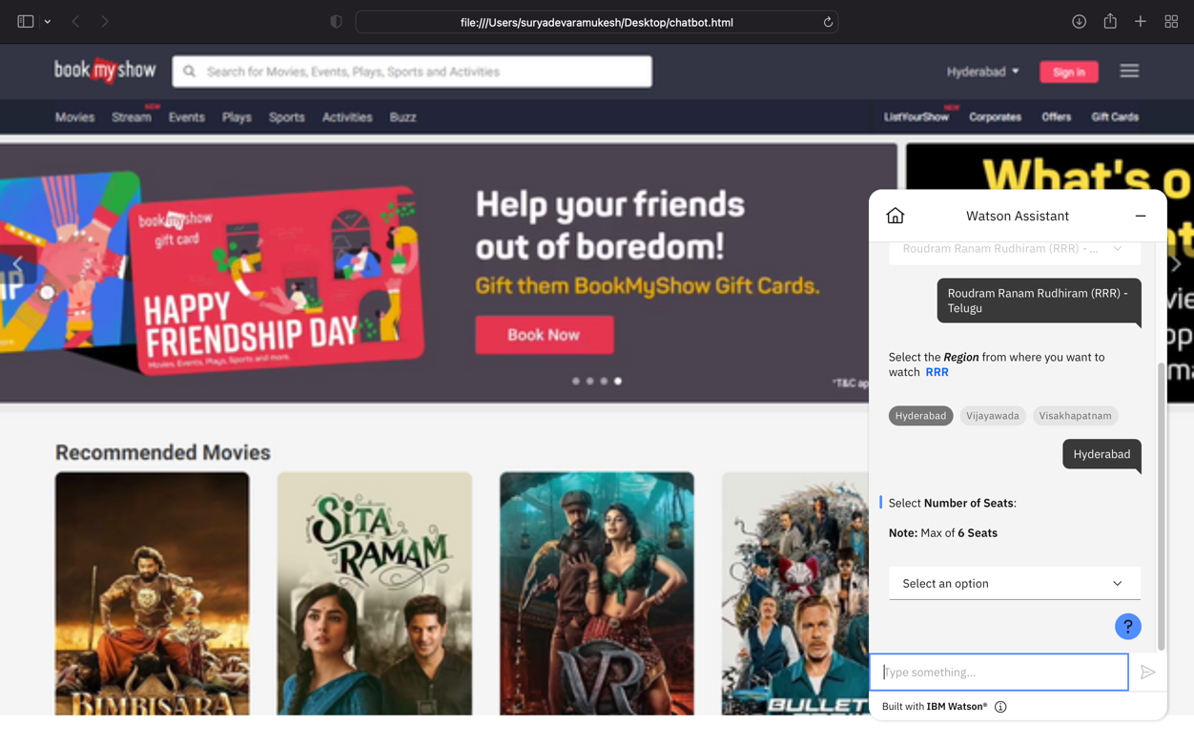

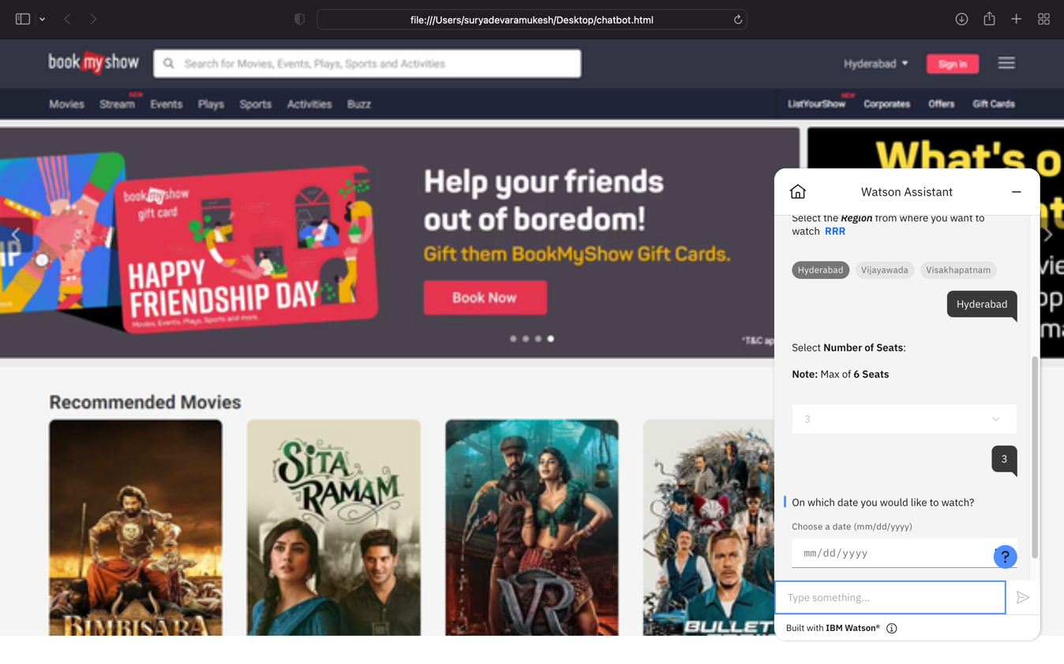

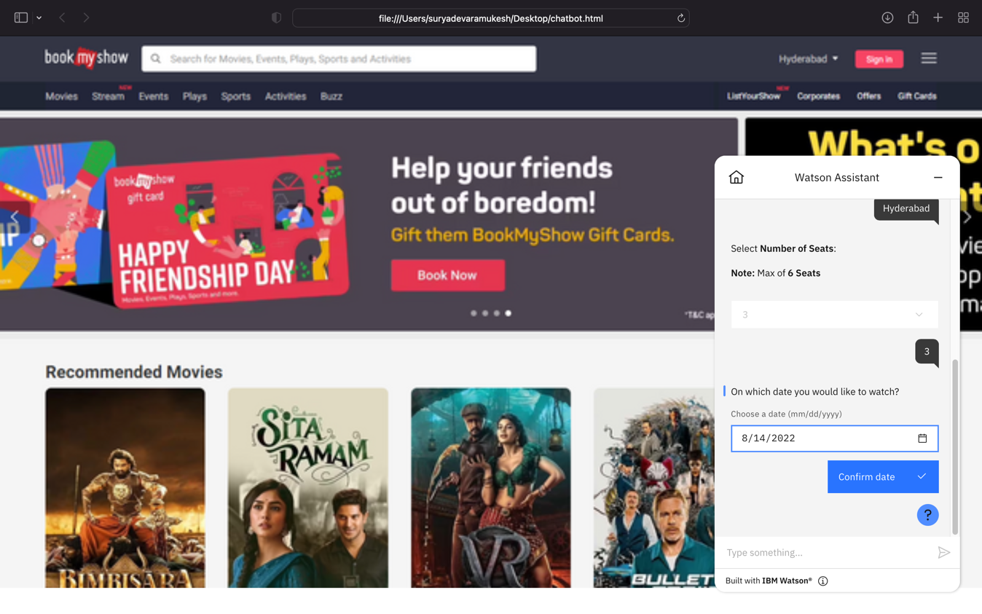

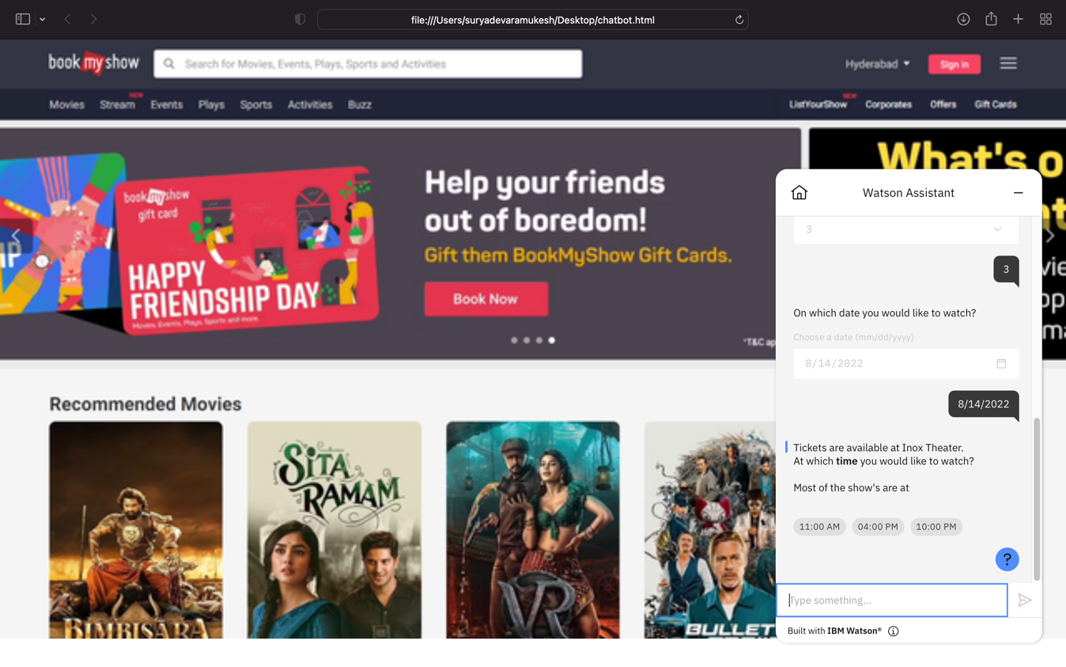

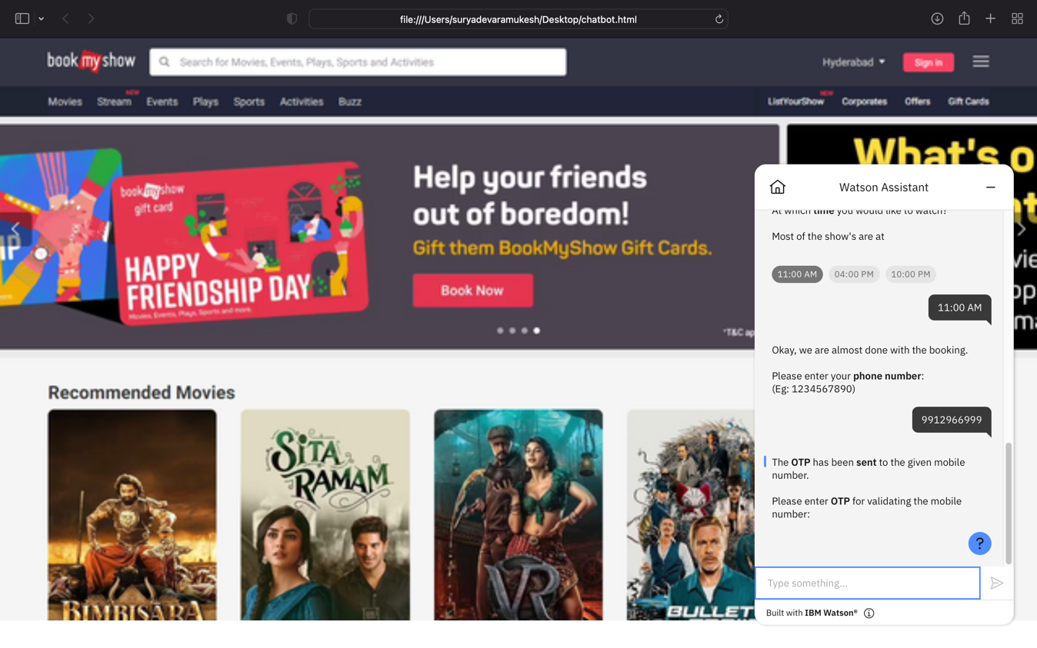

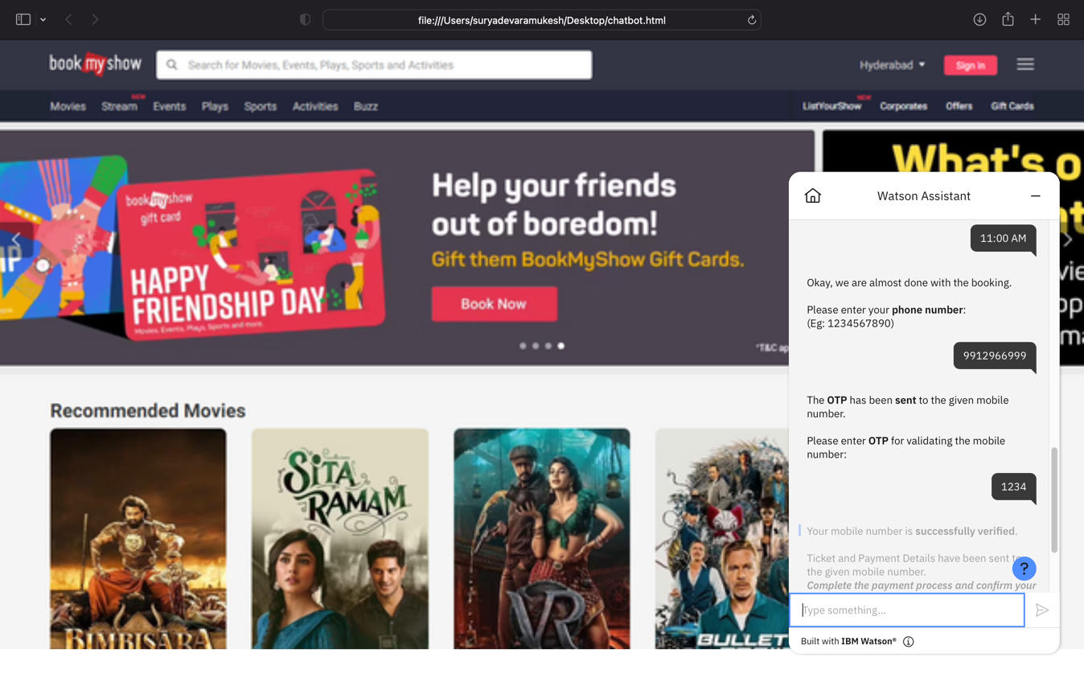

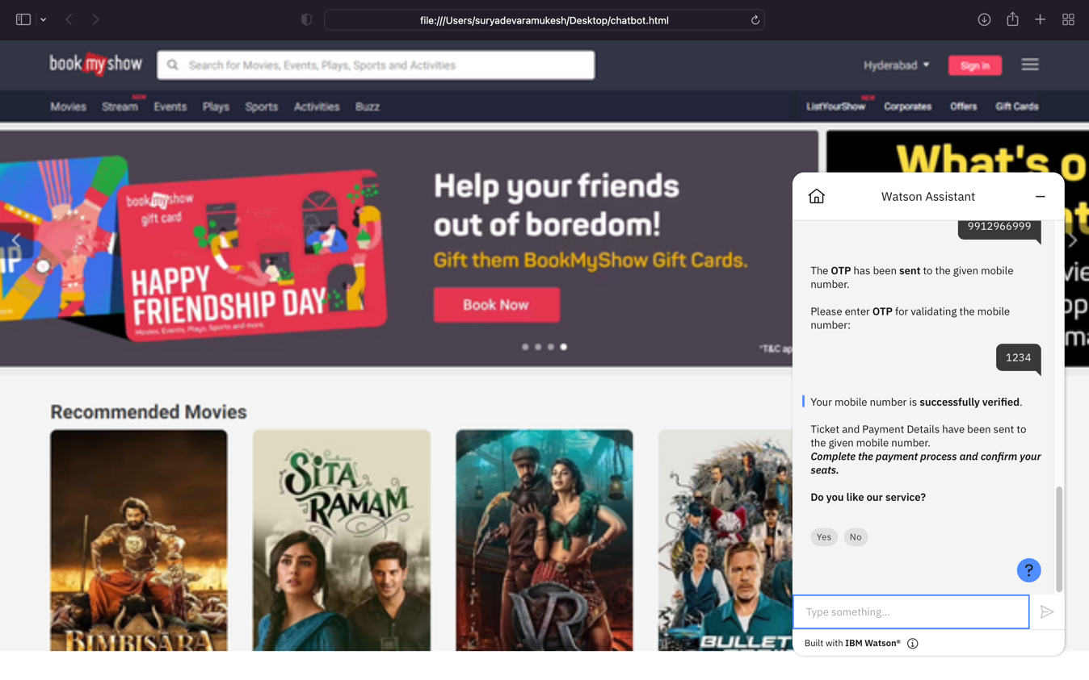

1. **ADVANTAGES AND DISADVANTAGES**
   1. **Advantages**

* Faster Customer Service.
* Constantly Available for Customers.
* Promotes Conversational Marketing.
* Helps in Managing Customer Requests.
  1. **Disadvantages**
* Do not Understand Natural Language.
* Not Personalized or Emotive.
* Higher Capacity for Misunderstanding.
* Need to be Maintained.
* Tickets might not be booked in a row.

1. **APPLICATIONS**

* Content delivery
* Ordering Food
* Flight Bookings
* Market research
* Transportation
* Health care - Appointments
* Booking Movie Tickets
* Feedback from customers

1. **CONCLUSION**

The chatbot “Movie Ticketing Bot Powered by IBM Watson Assistant” was developed to make movie ticketing easier in terms of time.

The following conclusions can be deduced from the development of the project:

* Give the list of movies available
* The Bot should be able to show different show timings
* When a movie is selected the bot should show the availability of tickets
* The bot should be in a position to book tickets.

1. **FUTURE SCOPE**

Many more features can be integrated to give a better user experience to the customer, such as automating simple payments and allowing users to pay directly over live chat, and integrating as many theatres possible with the website so that every theatre will have profit and the customers also. This action indirectly decreases ticket prices.

1. **BIBILOGRAPHY**

[**https://in.bookmyshow.com/explore/home/hyderabad**](https://in.bookmyshow.com/explore/home/hyderabad)

[**https://www.pvrcinemas.com**](https://www.pvrcinemas.com/)

[**https://ieeexplore.ieee.org/document/8692927**](https://ieeexplore.ieee.org/document/8692927)

[**https://github.com/NerdyMunchies/Simple-Movie-Booking-Chat-Bot-using-Slots**](https://github.com/NerdyMunchies/Simple-Movie-Booking-Chat-Bot-using-Slots)

[**https://templates.botstar.com/chatbot-template/cinema-ticket-chatbot**](https://templates.botstar.com/chatbot-template/cinema-ticket-chatbot)

**Appendix**

* + 1. **Source Code**

[**https://github.com/smartinternz02/SI-GuidedProject-89748-1658128722/blob/main/Movie-Ticket-Booking-Bot-action.json**](https://github.com/smartinternz02/SI-GuidedProject-89748-1658128722/blob/main/Movie-Ticket-Booking-Bot-action.json)

* + 1. **Preview Link**

[**https://web-chat.global.assistant.watson.appdomain.cloud/preview.html?backgroundImageURL=https%3A%2F%2Fus-south.assistant.watson.cloud.ibm.com%2Fpublic%2Fimages%2Fhttps%3A~s~sin.bookmyshow.com~sexplore~shome~s&integrationID=4f933245-28d1-4a04-bb6c-c7394a5**](https://web-chat.global.assistant.watson.appdomain.cloud/preview.html?backgroundImageURL=https%3A%2F%2Fus-south.assistant.watson.cloud.ibm.com%2Fpublic%2Fimages%2Fhttps%3A~s~sin.bookmyshow.com~sexplore~shome~s&integrationID=4f933245-28d1-4a04-bb6c-c7394a562ea3&region=us-south&serviceInstanceID=8e1ab72d-6322-413c-a4fb-455718ceddd6)

* + 1. **Video Link**